PRESS RELEASE: 16th July 2023

Silver Cup podium for Michelotto and Nemoto

Fanatec GT World Challenge by AWS, Sprint Cup – Misano

After a two month pause the Fanatec GT World Challenge by AWS Sprint Cup resumed with a hot and sticky double header at Misano this weekend. A record grid of forty-two cars ensured both races were close and exciting. VSR entered three Lamborghini Huracan GT3 Evo 2 cars. The Pro entry number 60 was driven by Jordan Pepper and Franck Perera. Baptiste Moulin and Marcus Paverud shared the 119 Silver Cup car and Mattia Michelotto joined Yuki Nemoto behind the wheel of the 163, also entered in the Silver Cup.

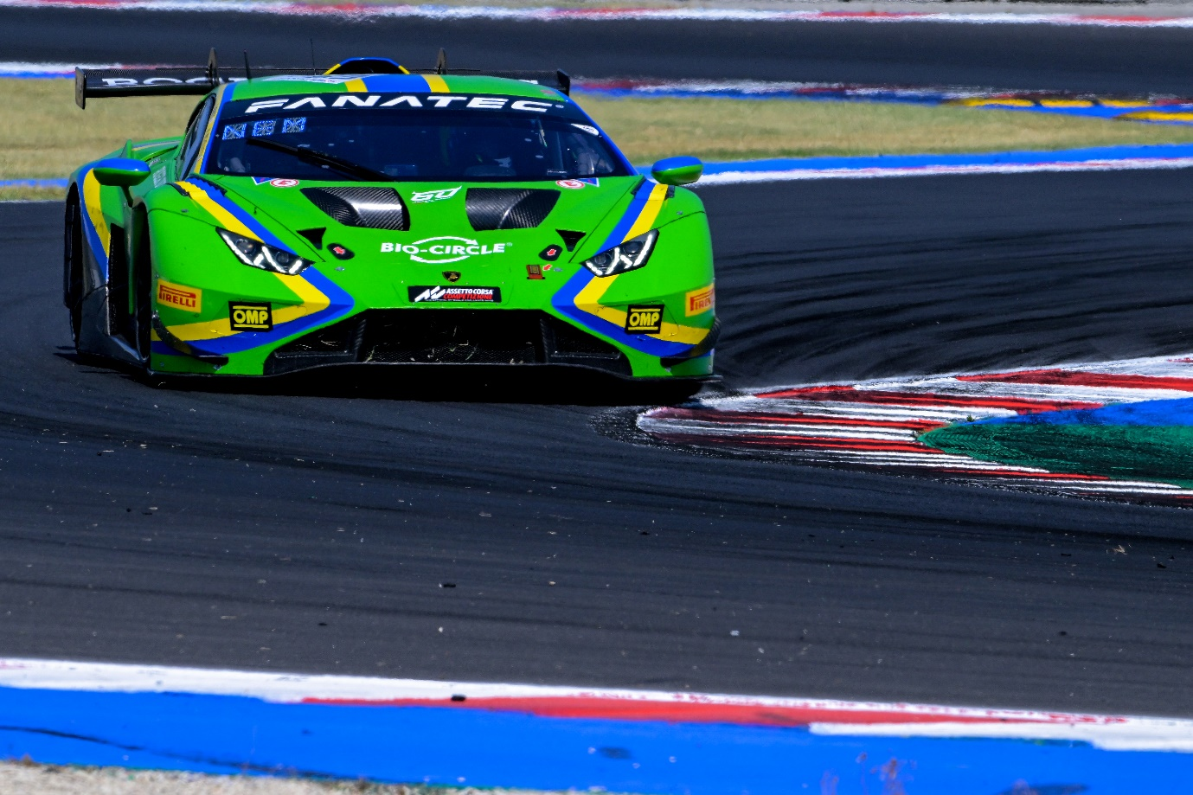
#163 – Mattia Michelotto / Yuki Nemoto (photo by Fotospeedy)

Qualifying for Saturday’s race was undertaken by Perera, Moulin and Nemoto. Perera parked his Lambo on row eight and the Silver Cup cars qualified fifth in class (Nemoto) and seventh in class (Moulin). A four car collision at turn one caused chaos at the start and Perera took advantage of it to jump up to tenth as Nemoto and Moulin ran together fifth and sixth in class. On the second lap Nemoto passed Moncini for fourth in class and continued to move through the field until a pass on Delli Guanti resulted in contact which broke the rear suspension of the VSR Lamborghini. The pit window opened on lap sixteen and Moulin pitted for Paverud. Two laps later Perera handed over the 60 car to Pepper. A fast pit-stop allowed them to undercut several cars and when the pit window was closed Pepper was running in eighth. Paverud was fifth in the Silver Cup and spent his entire stint trying to find a way past Guidetti’s Honda. As the race entered the last quarter Pepper was fighting to hold off Martin, Haase and Drudi. Their battle became the highlight of the closing stages of the race and on lap thirty-one Pepper caught and passed Ramos’s McLaren for seventh. He was followed through by his pursuers but kept them behind him to take seventh at the chequered flag. Paverud finished fifth in class – another solid points scoring finish for the 119 car.

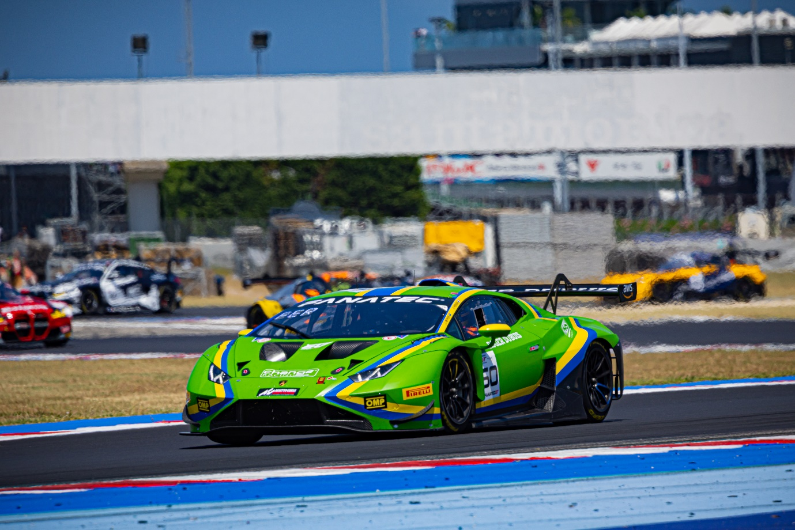
#60 – Jordan Pepper / Franck Perera (photo by Fotospeedy)

On Sunday morning it was the turn of Pepper, Paverud and Michelotto to qualify the cars. The Silver Cup cars were out in the first group and Michelotto held the class pole until the last seconds of the session when three cars improved demoting him to fourth in class by just one tenth of a second. He started from row eleven with Paverud just a few places behind him. Pepper lined up on row eight but by the end of the second lap was already up to tenth place and in the points. Michelotto had slipped behind Di Fabio at the start but soon got the better of the Honda and ran fourth in class, just behind Bird’s Mercedes, with Paverud in sixth. On lap eleven a Full Course Yellow followed by a Safety Car stopped racing and delayed the pit window. When racing went green Pepper pitted first and Perera took over the Pro car. A lap later Paverud stopped for Moulin but the car was delayed badly in the pits. Michelotto was the last VSR car to stop, pitting for Nemoto on lap eighteen. When the pit window closed Perera was running seventh and Nemoto and Moulin were second and eighth in class. Perera lost a place to a hard-charging Marciello but took the chequered flag in eighth, once more in the points. Nemoto came home second in Silver Cup, he and Michelotto taking the first podium for the 163 car. Moulin had just passed Zanotti when he was eliminated by a Porsche and forced to retire his Lambo just before the end of the race.

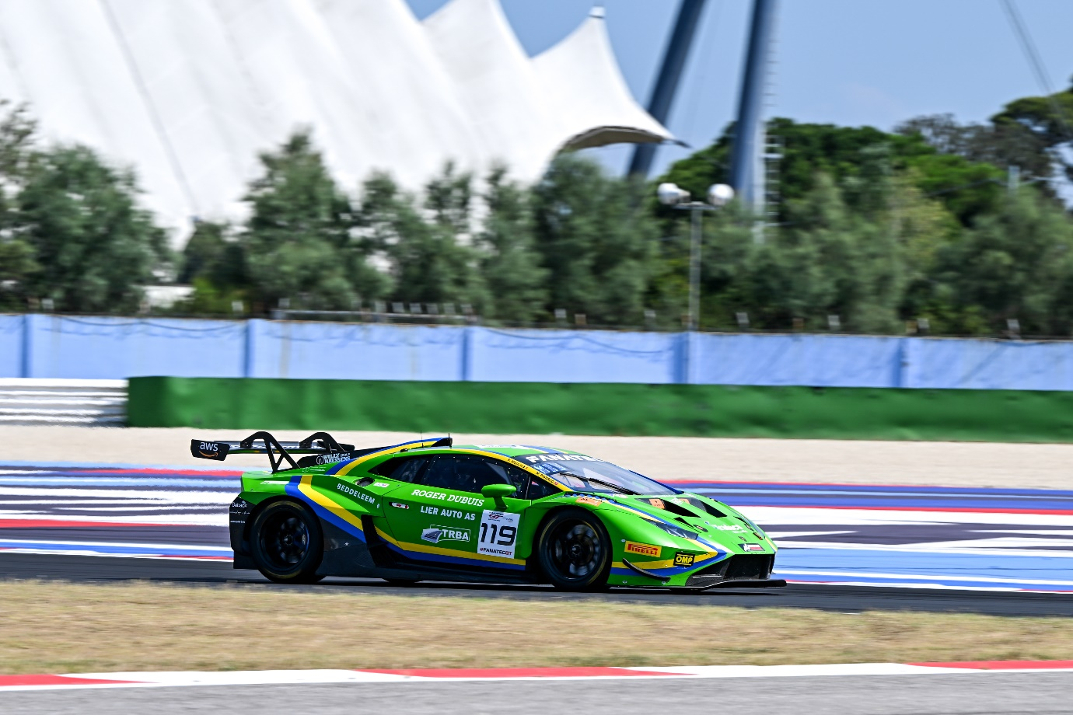
#119 – Baptiste Moulin / Marcus Paverud (photo by Fotospeedy)

VSR will be back in action in a fortnight’s time for the third round of the European Lamborghini Super Trofeo Championship at the Nurburgring.

- ENDS -

